MODULE – Advance PHP

Q-1) What Is Object Oriented Programming?

Ans-1) PHP is a server-side scripting language and used for web development but also used as a general-purpose programming language. Object-Oriented Programming (OOP) is a programming paradigm that revolves around the concept of objects and classes. It's a way of designing and organizing code to simulate real-world objects and systems.

Q-2) What Are Properties Of Object Oriented Systems?

Ans-2) Object Oriented Systems Properties are below:

* Encapsulation: Bundling data and methods that manipulate that data into a single unit (object). And use private, protected, and public visibility keywords to control access to class members (properties and methods).
* Inheritance: Creating new classes based on existing ones, inheriting their properties and behavior. And use the extends keyword to create a subclass.
* Polymorphism: Objects of different classes responding to the same method call. And Achieved through method overriding and interfaces.
* Abstraction: It is to handle complexity by hiding unnecessary details from the user and use abstract classes and methods.

Q-3) What Is Difference Between Class And Interface?

Ans-3) Key differences between class and interface:

* Classes can have implementation code, while interfaces only declare method signatures.
* Classes can be instantiated, while interfaces cannot.
* Classes support single inheritance, while interfaces support multiple inheritance.
* Classes are for creating objects, while interfaces define a contract for classes to follow.

Q-4) What Is Overloading?

Ans-4) Method overloading is a feature in object-oriented programming (OOP) that allows multiple methods with the same name to be defined, as long as they have different parameter lists.

Multiple methods can have the same name. Different parameter lists: Each method must have a unique set of parameters, either in:

Number of parameters

Parameter data types

Parameter order

Same return type: Not required, but often the same

Q-5) What Is T_PAAMAYIM_NEKUDOTAYIM (Scope Resolution Operator (::) with Example.

Ans-5) The scope resolution operator also known as Paamayim Nekudotayim or more commonly known as the double colon is a token that allows access to static, constant, and overridden properties or methods of a class.

It is used to refer to blocks or codes in context to classes, objects, etc. An identifier is used with the scope resolution operator. The most common example of the application of the scope resolution operator in PHP is to access the properties and methods of the class.

Example: This type of definition is used while defining constants within a class.

<? php

class democlass {

const PI = 3.14;

}

echo democlass::PI;

?>

Output: 3.14

Q-6) What are the differences between abstract classes and interfaces?

Ans-6) Difference between Abstract class and Interfaces.

Abstract class:

* Abstract class comes under partial abstraction.
* Abstract classes can maintain abstract methods and non abstract methods.
* In abstract classes, we can create the variables.
* In abstract classes, we can use any access specifier.
* By using 'extends' keyword we can access the abstract class features from derived class.

Multiple inheritance is not possible.

Interface:

* Interface comes under fully abstraction.
* Interfaces can maintain only abstract methods.
* In interfaces, we can't create the variables.
* In interface, we can use only public access specifier.
* By using 'implement' keyword we can get interface from derived class.
* By using interfaces multiple inheritance is possible.

Q-7) Define Constructor and Destructor?

Ans-7) A constructor is a special method in a class that is automatically called when an object of that class is created. It has the same name as the class

Syntax:

* __construct():

function __construct()

{

// initialize the object and its properties by assigning

//values

}

* __destruct(): A destructor is a special method in a class that is automatically called when an object of that class is destroyed or goes out of scope. It is used to Release resources (e.g., close database connections) and Clean up memory.

function __destruct()

{

// destroying the object or clean up resources here

}

* The constructor is defined in the public section of the Class. Even the values to properties of the class are set by Constructors.

Q-8) How to Load Classes in PHP?

Ans-8) PHP load classes are used for declaring its object etc. in object oriented applications. PHP parser loads it automatically, if it is registered with spl_autoload_register() function. PHP parser gets the least chance to load class/interface before emitting an error.

Syntax:

spl_autoload_register(function ($class_name) {

include $class_name . '.php';

});

Q-9) How to Call Parent Constructor?

Ans-9) We will face two cases while calling the parent constructor method in child class.

* We can't run directly the parent class constructor in child class if the child class defines a constructor. In order to run a parent constructor, a call to parent::__construct() within the child constructor is required.

Example:-

<?php

class grandpa{

public function __construct(){

echo "I am in Tutorials Point".;

}

}

class papa extends grandpa{

public function __construct(){

parent::__construct();

echo "I am not in Tutorials Point";

}

}

$obj = new papa();

?>

Output: I am in Tutorials Point

I am not in Tutorials Point

Explanation:-

In the above example, we have used parent::__construct() to call the parent class constructor.

* If the child does not define a constructor then it may be inherited from the parent class just like a normal class method(if it was not declared as private).

Example

<? php

class grandpa{

public function __construct(){

echo "I am in Tutorials point";

}

}

class papa extends grandpa{

}

$obj = new papa();

?>

Output: I am in Tutorials point

Explanation:-

Here the parent class is called implicitly because in child class we have not declared any constructor function in child class.

Q-10) Are Parent Constructor Called Implicitly When Create An ObjectOf Class?

Ans-10) Parent constructors are not called implicitly if the child class defines a constructor.

Q-11) What Happen, If Constructor Is Defined As Private Or Protected?

Ans-11) You cannot create an instance of class A from outside the class using that particular constructor which is declared private. Any member of a class declared as private can only be accessed from within the class only.

A constructor is defined private in certain design patterns like Singleton where the idea is to have a single instance created for a class during the entire life span of the program.

Q-12)What are PHP Magic Methods/Functions? List them Write program for Static Keyword in PHP?

Ans-12) Magic methods in PHP are special functions prefixed with __ (double underscore) that empower developers to dynamically handle events and operations in classes. They modify how class properties, method calls, and other operations work, making classes more adaptable to specific needs.

List of Magic Methods in PHP

Here is a list of commonly used magic methods in PHP:

* __construct(): This magic method is the constructor of a class and is automatically called when an object is created. It is used to initialize object properties and perform any necessary setup.
* __destruct(): The __destruct() magic method is called automatically when an object is no longer referenced or when the script finishes execution. It is used to perform cleanup tasks or release resources held by the object.
* __get(): This magic method is invoked when accessing inaccessible or non-existent properties of an object. It allows you to define custom logic for retrieving the value of a property.
* __set(): The __set() magic method is triggered when assigning a value to an inaccessible or non-existent property of an object. It allows you to define custom logic for setting the value of a property.
* __isset(): This magic method is called when using the isset() function to check if an inaccessible or non-existent property of an object is set. It allows you to define custom logic for checking the existence of a property.
* __unset(): The __unset() magic method is invoked when using the unset() function to unset an inaccessible or non-existent property of an object. It allows you to define custom logic for removing a property.
* __call(): This magic method is triggered when invoking inaccessible or non-existent methods of an object. It allows you to define custom logic for handling method calls.
* __to String(): The __to String() magic method is called when an object is treated as a string, such as when using the echo or print functions. It allows you to define a string representation of the object.

The static keyword is used to declare properties and methods of a class as static. Static properties and methods can be used without creating an instance of the class.

Example:-

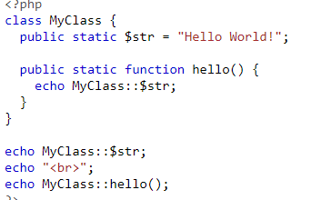

Output: 

Q-13) Create multiple Traits and use it in to a single class?

Ans-13) In PHP, it is possible to use multiple traits in a single class using the use keyword followed by the names of the traits separated by commas. This allows a class to reuse code from multiple traits, providing more flexibility and reducing code duplication.

Here is an example of using multiple traits in a single class:

trait TraitA {

// trait A code here

}

trait TraitB {

// trait B code here

}

class MyClass {

use TraitA, TraitB;

// class code here

}

Explanation : In this example, the MyClass class uses both TraitA and TraitB. This allows the class to reuse code from both traits and avoid duplicating code. Run the above code in your editor for a better and clear explanation.

If there are methods with the same name in multiple traits, the class must provide an implementation of the method to avoid a fatal error. Here is an example of using multiple traits with conflicting method names:

<?php

trait TraitX {

public function conflictMethod() {

echo "TraitX conflictMethod\n";

}

}

trait TraitY {

public function conflictMethod() {

echo "TraitY conflictMethod\n";

}

}

class AnotherClass {

use TraitX, TraitY {

TraitX::conflictMethod insteadof TraitY;

TraitY::conflictMethod as anotherConflictMethod;

}

}

$anotherObject = new AnotherClass();

$anotherObject->conflictMethod(); // Output: TraitX conflictMethod

$anotherObject->anotherConflictMethod(); // Output: TraitY conflictMethod

?>

Q-14) Write PHP Script of Object Iteration?

Ans-14) A foreach loop may be employed to iterate through all the publicly visible members of an object of a PHP class.

PHP also defines Iterator interface which can be used for the purpose.

Example:

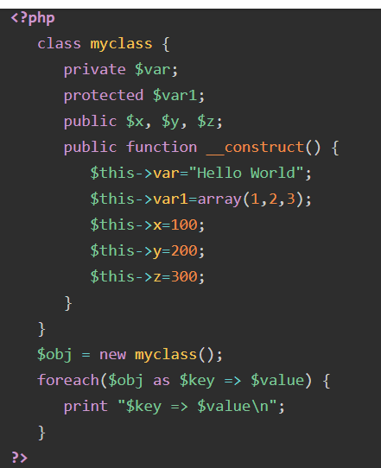

Output:

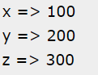

Q-15) Use of The $this keyword

Ans-15) The $this keyword lets us use our class methods and properties. This means that we can, for example, call a method or a property within the current class itself.

Example:

class Dog {

public $name;

public $age;

public function intro(){

echo 'This is '.$this -> name . 'and it is ' .$this -> age . 'old.';

}

}